Project 7: FinOps for Networking (Connectivity Cost Models)

Every network choice costs money. This project helps teams see the cost before they build, so there are no surprise bills.
- Where the money goes: Transit Gateway attachments and data processed, NAT gateways, firewalls and inspection, Direct Connect, and data moved across Availability Zones or Regions.
- Bandwidth planning: pick link sizes from measured traffic, not guesses.
- Inspection trade-offs: checking all traffic is safer but costs more.
- Your job: give guidance on cost models and trade-offs. Check current prices on the AWS pricing pages.

Network diagram
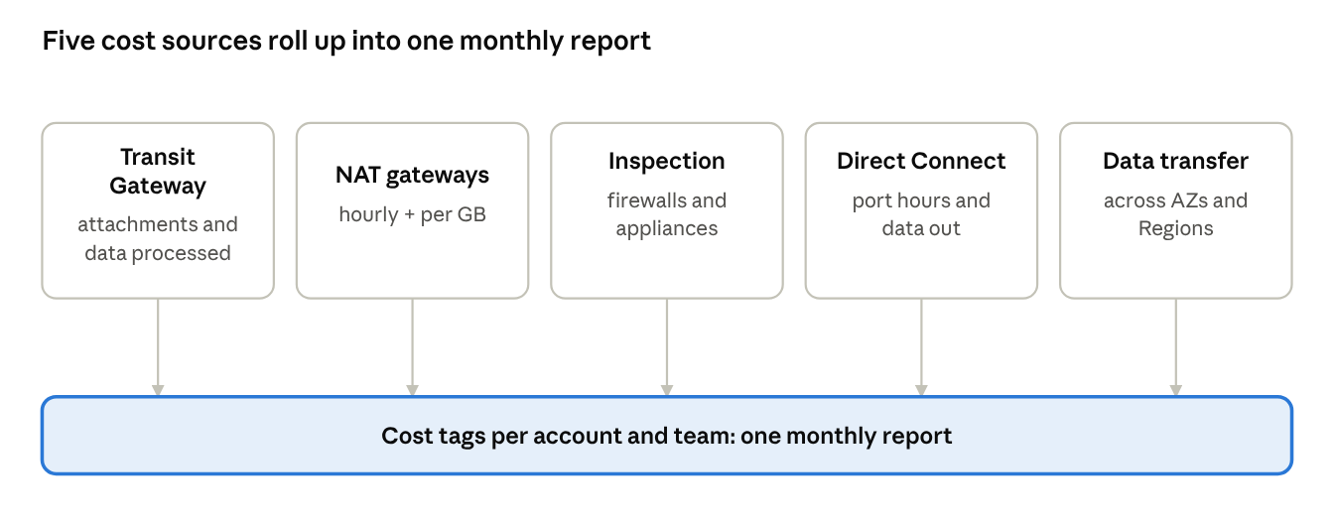
network cost sources · 5 sources, 1 report
Each cost source is tagged by account and team, so one monthly report shows who spends what on the network.

Cost models and trade-offs
Decision | The trade-off in simple words
Transit Gateway or VPC Peering | TGW is easier to manage but adds attachment and per-GB charges. Peering has no hourly fee but is harder to run at scale.
Inspect all traffic or only some | Full inspection gives the most control. It adds firewall cost and a little delay. Inspect high-risk paths and keep trusted ones simple.
One shared NAT or one per VPC | Shared NAT can cost less. Per-VPC NAT is simpler and keeps problems small.
Link size | Size Direct Connect from measured peak traffic plus growth, and keep a backup.
Cost tags | Tag every account and network resource so costs can be shown per team.

Production use case
Example scenario: a company moves 30 apps to AWS and the network bill is higher than planned.
- The team tags traffic by account and finds that nightly backups to Amazon S3 pass through NAT and the firewall.
- They add S3 gateway endpoints, so that traffic skips NAT and inspection.
- They keep full inspection on internet-facing paths.
- They share a monthly cost report with each app team.
Result: lower network cost, security kept where it matters, and teams who can see what they spend.

Interview questions and answers
Practice questions at the depth that senior cloud-network interviews at companies like AWS, Google and Meta expect. They are not official lists.
Q1. Network cost doubled after a migration. How do you find out why?
Break the bill down by service and by account using Cost Explorer and the Cost and Usage Report. Look at Transit Gateway data processed, NAT gateway data, cross-AZ and cross-Region transfer, and inspection. Use flow logs to find the heaviest flows.
Q2. How do you cut NAT gateway cost?
Use VPC endpoints for AWS services. A gateway endpoint for S3 has no hourly or data charge. Keep chatty traffic inside the VPC, and review which workloads really need internet access.
Q3. Transit Gateway or VPC Peering from a cost point of view?
Transit Gateway adds attachment and per-GB charges but is much easier at scale. Peering has no hourly fee but links multiply. For two or three VPCs with heavy traffic, peering can be cheaper. For dozens of VPCs, the operating effort usually favours TGW.
Q4. How do you decide how much traffic to inspect?
Base it on risk. Inspect internet-facing and cross-network paths fully. Trusted internal paths can be inspected less or not at all. Write the decision down with the security team, and revisit it with cost data.
Q5. Direct Connect or VPN: how do you decide?
Compare monthly cost against traffic volume, steady speed needs and latency needs. Direct Connect usually wins when traffic is large and steady. VPN fits small or temporary needs. Many designs keep VPN as a backup.
Q6. How do you make teams care about network cost?
Tag every account and resource, send each team a monthly report, and show cost per unit of work such as cost per GB moved. Set alerts for sudden jumps so teams find problems early.

